Week Two Assessment BONUS

(responses in red)

**Identify 3 software or technology companies the interest you.**

The companies are:

Blockchain Technology – Finance Software

Oracle – Computer Software Company

Microsoft – Computer Software Company

**Conduct research to figure out some or all of the elements of each company’s technology stack. Check job openings/job descriptions, engineering blogs, and anything else that may have information about what the company uses to write/build its software products.**

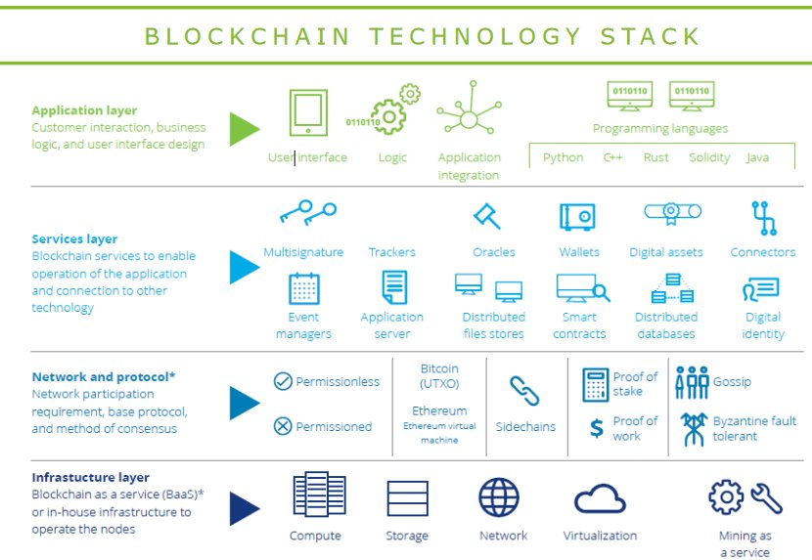Blockchain Techstack Diagram

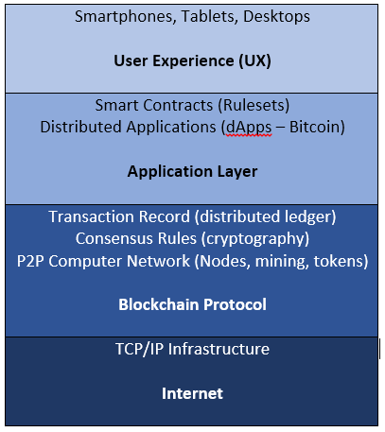

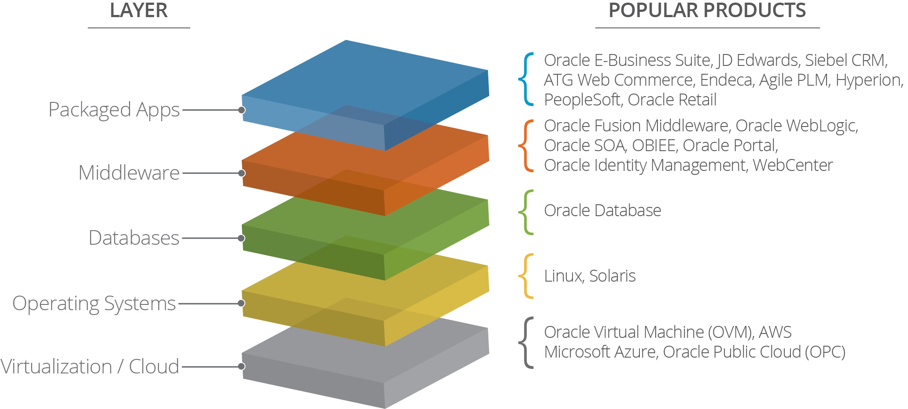Oracle Technology Stack Diagram

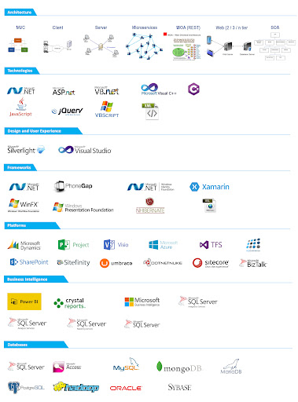

Microsoft Technology Stack Diagram

**Record your findings in a google doc. If you can find information about why the company chose that stack, include that as well.**

Save your files and push them to GitHub with your code.